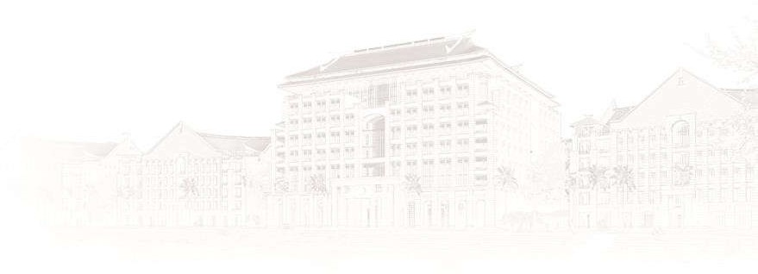

Recommendation Letter

**Mar 23, 2023**

**Xiamen University Malaysia, Jalan Sunsuria,**

**Bandar Sunsuria, 43900 Sepang, Selangor Malaysia**

Dear Admissions Committee,

It is my privilege to write this letter of recommendation for Liu Aofan, who has been an outstanding student in my Program Elective course. We have known each other for alomost a year. Liu Aofan has demonstrated remarkable engineering skills and has excelled in the course, consistently producing work of exceptional quality.

During the course, Liu Aofan built a mobile app using Kotlin language and MySQL, which was impressive and reflected his knowledge and skills. He showed great enthusiasm and initiative throughout the course, always going beyond the requirements of the assignments and projects. Liu Aofan demonstrated a deep understanding of industry standards and best practices, and his work was of high quality.

Liu Aofan's passion for technology and his ability to apply theoretical knowledge to practical applications is admirable. He has a strong interest in pursuing an academic career and furthering his education in the field of engineering. With his exceptional aptitude and passion for technology, I am confident that Liu Aofan will make significant contributions to the academic community.

In conclusion, I highly recommend Liu Aofan for admission to your esteemed institution. He is a highly qualified candidate who possesses a unique combination of technical skills, passion for technology, and dedication to academic excellence

Thank you for your time, and if you have any questions for me, please direct them to my contact email listed in this letter..

Yours sincerely,



SIMON LAU BOUNG YEW

School of Computing and Data Science

E-mail: [simonlau@xmu.edu.my](mailto:simonlau@xmu.edu.my) Phone:+ 60163767236

XMU JIAGENG EDUCATION DEVELOPMENT SDN BHD

Company No: 201201038124 (1022606-P)

Xiamen University Malaysia DULN009(B)

A:Jalan Sunsuria, Bandar Sunsuria 43900 Sepang, Selangor Darul Ehsan, Malaysia.

Tel: +603 8800 6800 (Malaysia) +86 592 2183989 (China) W: [www.xmu.edu.my](http://www.xmu.edu.my/) E: [enquiry@xmu.edu.my](mailto:enquiry@xmu.edu.my)